**AP United States History**

Erin Tenczar

Room 631

[erin.tenczar@fortbendisd.com](mailto:erin.tenczar@fortbendisd.com)

**OVERVIEW**

AP United States History will resemble a freshman college introductory course to American history. It will be a challenging experience and students should expect the workload to be comparable to what college demands. As it is taught at a high school, this course meets five days a week. It is assumed that students have a high level of interest and competence in history prior to beginning this course. AP United States History includes components of political, social, economic, cultural, diplomatic, and intellectual history. The focus will be on providing students with the analytical skills and factual knowledge necessary to deal critically with the problems and materials in U.S. History. The course will also provide multiple mechanisms to make connections from the past to the present as well as contemplating the experiences of the varied and diverse perspectives of the people in the United States. The application of those skills will culminate with the AP United States History examination in May. Students will work to improve reading and writing skills through nightly reading assignments and consistent writing assignments. Students will be expected to participate daily in class discussions of assigned readings. The skills students enhance during this course will assist them during their college years and in lifelong learning.

Ultimately, students are preparing to take the AP United States History Exam given each year in May. By developing the above-mentioned skills, students will prepare for the four components of the Exam. On a regular basis, students will experience Multiple-Choice exams, Short Answer Questions, Document Based Questions and Long Essay Questions.

**THEMES**

As you study and prepare for the AP U.S. History Exam, we will cover various themes during the discussions of our nation’s history. As these themes are also highly recommended by the College Board, your ultimate goal is to look at a well-rounded and developed view of our past. These themes include the following:

1. American and National Identity

2. Work, Exchange, and Technology

3. Geography and the Environment

4. Migration and Settlement

5. Politics and Power

6. America in the World

7. American and Regional Culture

8. Social Structures

It is only by incorporating these concepts into our studies can we truly appreciate our own history. As most students have already taken at least one American history course, basic factual knowledge is assumed. We will work toward perfecting the “art” of history – interpretation of sources, analysis of conflicting viewpoints, and persuasive writing.

**THEME 1: AMERICAN AND NATIONAL IDENTITY**

This theme focuses on how and why definitions of American and national identity and values have developed among the diverse and changing population of North America as well as on related topics, such as citizenship, constitutionalism, foreign policy, assimilation, and American exceptionalism

**THEME 2: WORK, EXCHANGE, AND TECHNOLOGY**

This theme focuses on the factors behind the development of systems of economic exchange, particularly the role of technology, economic markets, and government.

**THEME 3: GEOGRAPHY AND THE ENVIRONMENT**

This theme focuses on the role of geography and both the natural and human-made environments in the social and political developments in what would become the United States.

**THEME 4: MIGRATION AND SETTLEMENT**

This theme focuses on why and how the various people who moved to and within the United States both adapted to and transformed their new social and physical environments.

**THEME 5: POLITICS AND POWER**

This theme focuses on how different social and political groups have influenced society and government in the United States as well as how political beliefs and institutions have changed over time.

**THEME 6: AMERICA IN THE WORLD**

This theme focuses on the interactions between nations that affected North American history in the colonial period and on the influence of the United States on world affairs.

**THEME 7: AMERICAN AND REGIONAL CULTURE**

This theme focuses on the how and why national, regional, and group cultures developed and changed as well as how culture has shaped government policy and the economy.

**THEME 8: SOCIAL STRUCTURES**

This theme focuses on how and why systems of social organization develop and change as well as the impact that these systems have on the broader society.

**UNITS OF STUDY** 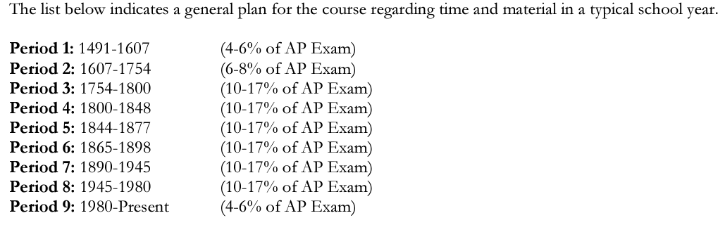

**GOAL**

Although optional, it is strongly encouraged that each student takes the AP Exam in May.

**TEST DAY: May 9, 2025 at 8:00 am.**

Registration for ALL AP Exams will be announced sometime in the Fall. More info to come.

**REQUIRED RESOURCES**

Textbook: American History: Connecting with the Past AP

Will be distributed to students hopefully the 2nd week of school

**SCHOOLOGY**

You will use Schoology frequently to access information/calendars, extra notes, key term lists, review items, and assignments. Schoology access is required. Please be prepared to access Schoology a couple of times per day on your cell phone, and computer.

**AP CLASSROOM**

AP Central is an online classroom that ALL AP students will be required to use. AP Classroom allows teacher and student to monitor the student’s learning through checkpoints. It is a requirement for each student to create **one** online account. You might already have an account because it was set up for you while taking the PSAT in 9th grade, the SAT in an earlier grade, or WHAP your sophomore year. AP, PSAT, SAT, ACT, and SAT II are all connected through College Board. Each student should have only **one** account with College Board.

If you do not know your login to the College Board website, we will work together to make sure it is done correctly. Avoid creating multiple accounts. If you have questions, ASK!

AP Classroom provides teachers and students access to a robust set of classroom resources. AP Classroom is a dedicated online platform designed to support teachers and students throughout their AP experience. The platform provides a variety of powerful resources and tools that offer yearlong support to teachers and enable students to receive meaningful feedback on their progress.

*PERSONAL PROGRESS CHECKS (PPC)*

Formative AP questions for every unit provide feedback to students on the areas where they need to focus.

Available online, Personal Progress Checks measure knowledge and skills through multiple-choice questions with rationales to explain correct and incorrect answers, and free-response questions with scoring information. Our class plan is to get our online classroom set up within the first three weeks.

<https://myap.collegeboard.org>

***My Course Code ___________________***

**REMIND**

Remind is a communication platform that allows teachers, students, and parents to communicate directly. Messages are sent in real time (as a text) to entire class, a small group, or individuals. You can download the remind app to join the class or you can use your text message app to join.

* Remind app: Click join a class and enter the class code: 72dkfh
* Text messaging app: text the message @72dkfh to the number 81010

**RECOMMENDED RESOURCES**

AP Review Book: Not only will the review book be a crucial tool in studying for the AP Exam, it will enable students to practice the high level of questioning, critical thinking, and writing skills (short answer essays, comparatives, change over time, and Document Based Questions) that come with Advanced Placement classes. There are numerous great publishers out there, but please make sure it is the most recent, updated material.

**REQUIRED DAILY SUPPLIES**

* Binder:
  + Can share with other classes
  + Needs to have a divider for assignments and another for notes
* loose-leaf notebook paper
* pens and pencils

*Classroom Supplies:*

* *Required* – Check out an AP US History Textbook from the school*.* This book is to be kept at home and will be used for reading assignments and studying. Students will return the textbook at the end of the year.

**GRADES**

Nine Weeks Grade: 50%--Major Grades and 50%--Daily Grades

A= 90--100%

B= 80—89%

C= 70—79%

F= 0—69%

**LATE WORK POLICY (AP)**

Students have a maximum of *THREE* days to turn in late work

* **1 day late – 15 points off**
* **2 days late – 30 points off**
* **3 days late – 50 points off**
* **> 4 days late - 100 points off *\*\*NO WORK WILL BE ACCEPTED AFTER 3rd DAY\*\****

**CLASSROOM GUIDELINES**

* Show RESPECT for yourself, your classmates, your teachers, and your school at all times.
* Be seated and ready to begin class when the bell rings.
* BE prepared! APUSH is challenging but rewarding. Get ready!
* Follow rules outlined in the FBISD Student Handbook and KHS campus expectations.
* Follow the Academic Honesty Policy!!!! This, above all else, will directly impact you as an AP Student.
* If you don’t know – ASK! You got this!

**The BIG Picture**

* Secure access to Schoology, AP Classroom, and the online textbook.
* Use a calendar or planner to keep yourself organized.
* Sign up for a club or extracurricular activity if you have not already done so. Colleges want to see an involved student leader, not just a straight A student.
* You will be assigned frequent readings in class and be expected to do your homework on a weekly basis. Reading quizzes are common.
* Advanced Placement is focused on Critical Writing. BE PREPARED to write in this course.
* Academic Honesty is a major focus for AP Teachers – do not lose the trust of your teachers, counselors, coaches, and administrators. The edge gained by cheating won’t be worth the loss when caught.
* Be prepared to work in groups, hold discussions in class, and use your notetaking skills.